|  |  |  |
| --- | --- | --- |
| Digital Assignment-1 | | |
|  |  |  |
| Prashanth.S 19MID0020 | | |

# Question-1

# Question-2

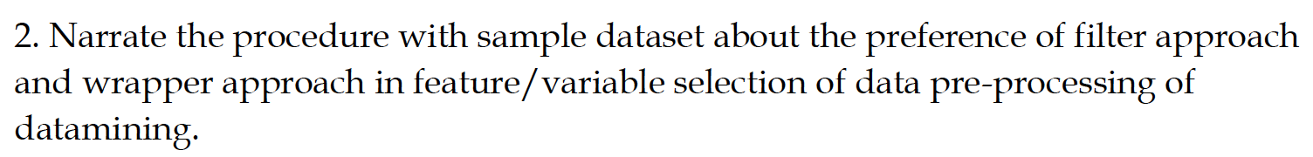

# Question-3

